LAB 04

IT24200320

Siribaddana D S

01)

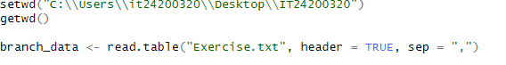

(02),(03)

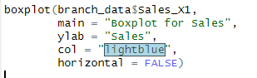

(04)

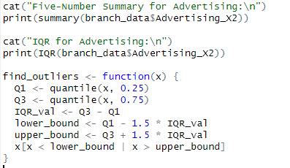

(05)

